Sign up to list your community group on the public Directory of Community Biodiversity Projects in Norfolk www.norfolkbiodiversity.org/communityprojects/

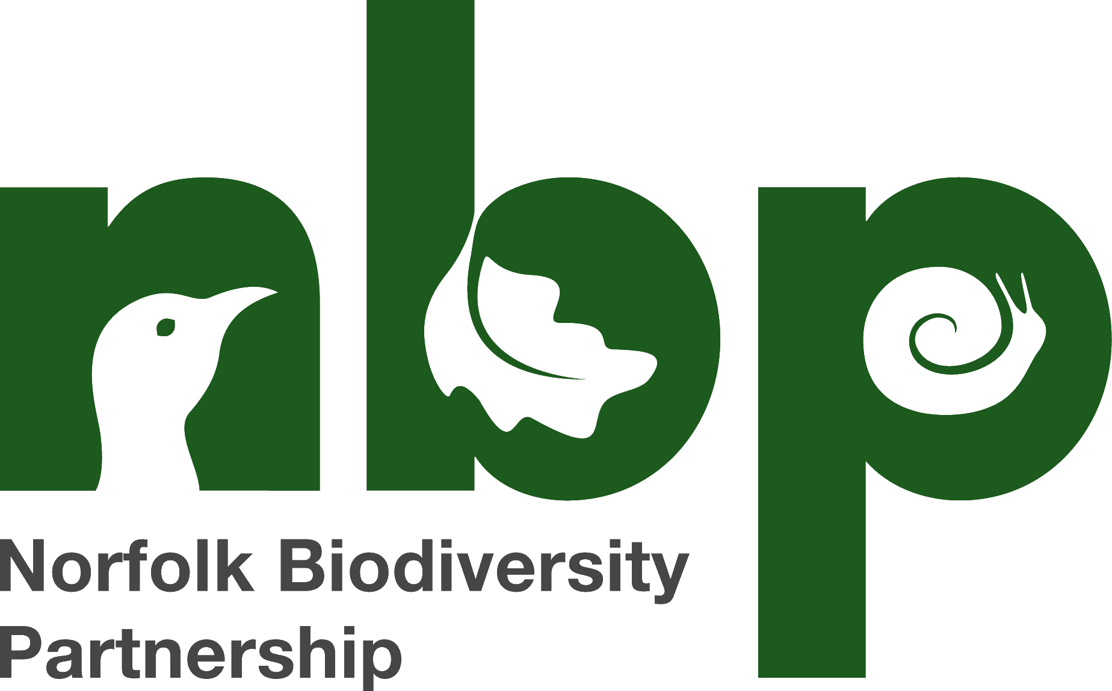

Directory of Community Biodiversity Projects in Norfolk
www.norfolkbiodiversity.org/communityprojects/

ABOUT THE DIRECTORY

All across Norfolk there are groups of people who have come together to take action voluntarily for wildlife and local places. Some of these groups are tackling a particular one-off project like restoring a pond, whilst others are improving and looking after a whole site like a community woodland, health or churchyard. Some groups are roving, working on a number of sites regularly whilst other are surveying and helping a single groups of animals like bats or toads.
These groups contribute a very significant amount to Norfolk’s biodiversity and the quality of the local environment. Some groups are very new whilst others have been going for over 40 years.
In this online public directory you can find information about your nearest group. They’ll be pleased to hear from you, especially if you are offering your help even if it’s just for a few hours.
You may be involved in one of these groups already and want to pick the brains of other groups tackling the same kind of project – for example if you are thinking of restoring a pond you can ask around for advice on disposing of the spoil or feedback on contractors. You might want to organise a group visit to get ideas or to invite others to your open event.
Finally, we hope the directory demonstrates the commitment that volunteers in communities across Norfolk are making to accommodate biodiversity and to improve the local environment for the benefit of us all. With continuing pressures on biodiversity and habitats from all sides including development, neglect, changes in agriculture and climate change coupled with diminishing resources available from public and charitable bodies, voluntary action from concerned individual in the community becomes ever more important, Besides that, its’ a great way to spend your spare time, keep fit and enjoy our fantastic Norfolk biodiversity.

Listing your group’s activities in the Directory is a great way to tell people about what you do and what your group can offer. Complete the attached form to do this.

Marya Parker, Vice-chair of the Communities and Nature Topic Group, and initiator of the Directory of Community Biodiversity Projects for Norfolk.

SIGN UP to include your group on the public Directory of Community Biodiversity Projects in Norfolk www.norfolkbiodiversity.org/communityprojects/
A notice about how this information will be used is appended to the form.
Please return this form to biodiversityawards@norfolk.gov.uk

Please complete the following information for your group or project which we will add to the public Directory of Community Biodiversity Projects in Norfolk which will be published on www.norfolkbiodiversity.org/communityprojects Please leave blank any data that you do not wish to share in this way.
Group name
Contact name
Telephone number
Address
Postcode
Email
Website
Aims of the group
Site type  Please indicate with a [x] all that are relevant | Grassland
 | Churchyard or cemetery
 | Commons or greens
 | Ponds
 | Fen or marsh
 | Heathland
 | Deciduous woodland
 | Coniferous woodland
 | Wet woodland
 | Traditional orchard
 | Hedgerow
 | River or canal
 | Lake
 | Coastal habitat
 | Allotment
 | School grounds
 | Other grounds (e.g. village hall)
 | Footpaths, Public Rights of Way and other paths
Activity types  Please indicate with a [x] all that are relevant | Grass cutting/hay making
 | Grazing
 | Scrub clearance
 | Removal of invasive species
 | Pond creation
 | Tree nursery
 | Coppicing
 | Tree planting
 | Pond management
 | Pond restoration
 | Hedgelaying
 | Wildlife/Community gardening
 | Species protection
 | Species survey
 | Growing food
 | Walks/educational activities
 | Path clearance
 | Construction e.g. hides, bridges
 | Tidy ups/litter picks
District Council area  Please indicate with a [x] all that are relevant | Broadland
 | Breckland
 | South Norfolk
 | North Norfolk
 | Norwich
 | Great Yarmouth
 | Borough of King’s Lynn and West Norfolk
Recent achievements
Recent challenges

Declaration. I consent to the above information being shared on the public Directory of Community Biodiversity Projects in Norfolk. [type YES] in the box. I understand I can apply at any time to the Norfolk Biodiversity Partnership (biodiversityawards@norfolk.gov.uk) to amend the information or to remove it from the Directory.
Your name (this will not be included on the Directory unless it is the same as information you have provided above). We will use it to contact you about administration for the Directory – see note on data use appended.
Your email (this will not be included on the Directory unless it is the same as information you have provided above). We will use it to contact you about administration for the Directory – see note on data use appended
Date

Please return this form to biodiversityawards@norfolk.gov.uk
How the information you have supplied will be used by the Norfolk Biodiversity Partnership
The Norfolk Biodiversity Partnership is a partnership between a number of local authorities, statutory agencies and voluntary groups which works to further the conservation of biodiversity in Norfolk www.norfolkbiodiversity.org. Norfolk County Council provides administrative support to the Partnership.

On behalf of the Partnership, the Directory of Community Biodiversity Projects is maintained by Norfolk County Council which takes care to ensure the accuracy and validity of the information. However, Norfolk County Council cannot accept responsibility or liability for any loss or claim arising directly or indirectly from any error or inaccuracy in any of the material in this directory.
- You should be aware that this is a public directory and users may share this information via email or on social networking sites. If you choose to provide information for our directory, you are consenting to the information you have supplied being shared in this way.
- You are also responsible for keeping this information up to date.
- We will include your information on the directory only for as long as you continue to give your agreement to the Norfolk Biodiversity Partnership that it can be used for this purpose.
- We will use the public contact information you have supplied to contact you ourselves from time to time about local biodiversity-related events, news and initiatives.
- You can withdraw your consent to the provision of your information for the above purposes at any time, or update the information held by contacting the Norfolk Biodiversity Partnership biodiversityawards@norfolk.gov.uk
- If you choose to supply personal information on the registration form which does not appear on the directory (your personal data) this will: (a) be used to administer your registration on the Directory (b) be used to make decisions about whether the content you submit should be accepted (c) not be made public (d) be held in accordance with Norfolk County Council’s privacy policy https://www.norfolk.gov.uk/what-we-do-and-how-we-work/policy-performance-and-partnerships/policies-and-strategies/corporate/data-protection/norfolk-county-council-privacy-notice

